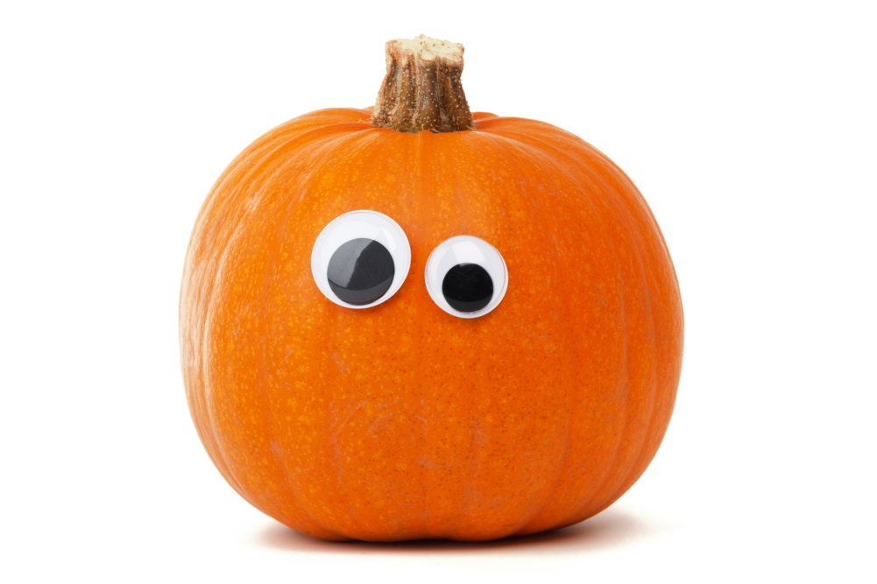

### Trinity Junior High

Ft. Smith, AR

Newsletter Date

October, 2015

Ms. Schmitz’s 7th Grade Life Science Classroom Newsletter

**Halloween party Friday!!**

# This Week’s Assignments

## Upcoming Events

**This week, we will be learning about the different types of organisms and their importance in the world. We’ll watch videos, do activities, answer some questions from the book, and have a lot of fun!**

**This Friday we will be having our Halloween party and watching a video about the different types of organisms.**

## Reminders to Students

* **Worksheet from last week are due Tuesday.**
* **Bring your assigned food item Friday for Halloween party.**
* **Be sure to study! There could be a quiz soon.**

## Reminders to Parents

* **Be sure to send your child with food on Friday! ☺**
* **Your child will need some supplies for their rock project. I will post the list on my website.**

Contact me!

Email: [mschmi00@g.uafs.edu](mailto:mschmi00@g.uafs.edu)